**Github link: https://github.com/Abijjam1/week2part3**

**ERD using UML**

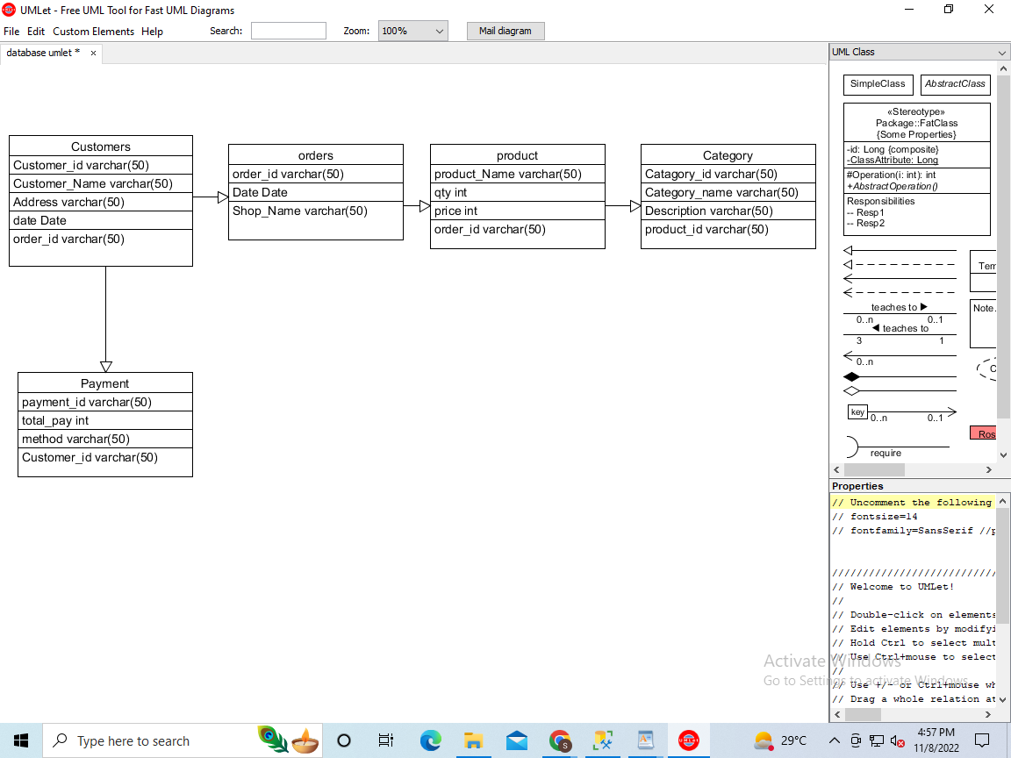

**ERD using Crow’s Foot notation**

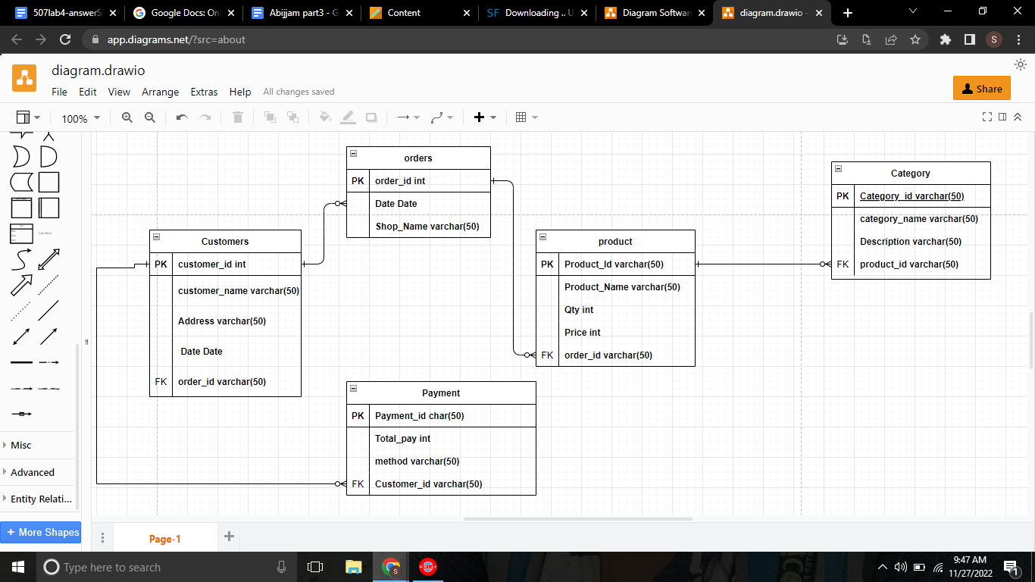

**Description of the relationships**

**1.Customer Table:**

**Description of relationships :** Customer table are relation to the orders and Payment table

**Description of keys :**  Customer_id is a primary key which is not null and order_id is a foreign key of Customer table

**2.orders Table:**

**Description of relationships :** orders table is linked to the product table

**Description of keys :** order_id is the primary key of the orders table

**3.product Table:**

**Description of relationships : product**  table are linked to the Category table by one to many relationship

**Description of keys :** product_id is the primary key of the product_id table which is not null and the order_ id is foreign key.

**4.Category Table:**

**Description of relationships : category**  table is linked to the product table

**Description of keys :** Category_id is a primary key, product_id is a foreign key

**5.Payment Table:**

**Description of relationships : payment**  table are linked to the Customers table from one to many relationship

**Description of keys:** payment id is a primary key Customer_id is a foreign key.